Halloween Virtual Cornhole
Fundraiser for 150th Anniversary WV School for the Deaf
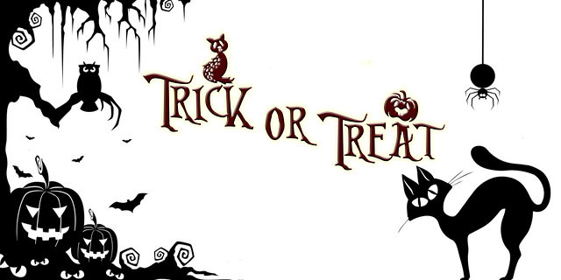
Friday, October 30, 2020 to Sunday, November 1, 2020
Double Elimination Tournament Registration Deadline: October 23, 2020 by 10:00 PM
Fee: $20 per team ($10 each) Friday, October 30, 2020 starts at 9:00 AM – 6:00 PM
Fundraiser $5.00 Saturday, October 31, 2020 starts at 9:00 AM – 6:00 PM
Prize Fee $15.00 November 1, 2020 If need to finish for champion starts at 9:00 AM

Registration Form
Name Player 1: _________________________________________________________________________________
Name Player 2: _________________________________________________________________________________
Required Phone Number: _________________________________________________________________________
Required E-mail: ________________________________________________________________________________

Please email boogold26@gmail.com your registration form, along with the $20.00 registration fee cash app to $SparklyCoffee. We accept cash app only. The winners will receive their prize monies through cash app.

For more information: Karen Booth 304.707.3198 VP or 304.844.3830 text or boogold26@gmail.com

Halloween Costumes are encouraged!
WVSD 150th Anniversary Virtual Cornhole Tournament Fundraiser
Rules and Regulation

Before you start participating in the tournament, you are required to participate in the Facebook group page under “150th Anniversary West Virginia School for the Deaf” to play. We will play 10 rounds of total points. The tournament will start on Friday, Oct. 30th.

1. Facebook Live Issues
- Games must be on Facebook Live stream.
- Make sure the WiFi is off and turn on “Do Not Disturb”
- If a game is interrupted or frozen for some reasons and not completed live, you will have to start where the video left off or take a forfeit.
- You are not ALLOWED to turn Livestream off on purpose to review your rounds or mistakes. You must continue your game until you complete the 10 rounds game, or the score will be finalize before 10 rounds end.

2.Scoring
- Both boards must be visible with a scorekeeper of frame.
- You as a player need to be completely visible in the game.
- If you are unable to be seen in any kind of frame in the live video, you will be asked to redo.
- Scorekeeper - iPad, Score tower, dry erase board, etc.
- To use to keep scores: Scoreholio app, Scoreboard app, Sport Cam app is a great app for any iPad or any mobile phone. You can use your laptop to use the scoreboard.
- Scores
Each bag on the box = 1 point
Each bag in the box = 3 points
Any bags touching the ground or “bounced” onto the
box do not count and are to be removed prior to the
next bag being thrown.
- You are mandated to:
- tag your opponents before you start the game or after you completed the game.
- After you completed your game click “finish” and make sure you also click “share”.

3. Winning Games
a) Play 10 rounds and your total points will be determined by comparing your opponent’s score.

For example, John Doe 45 points with 10 rounds
Jane Doe 50 points with 10 rounds
Jane Doe win 5 points.
(50 points – 45 points = 5 points)
- If you and your opponents are tied, you or your partner will be picked one to throw for 3 rounds to determine who will win the game.

4. Facebook’s Blocking
- Everyone who participates in the virtual tournament is REQUIRED to unblock (your “blocking”) of your opponent so he/she can view and confirm the game itself.
- If you refuse to unblock, your game will be disqualified.

5.Boards
- The board must be 2 feet x 4 feet with 6 inches diameter.
- Boards must be set 27 feet apart.
- You are required to show the measurement before you begin your game.
- If you fail to show the measurement or wrong measure, you will get ZERO points.
- The measurement is from the nose of the board, not from the back of the board frame.

6. Weather
a) You can play cornhole inside garage, large building, or play outside.
b) If weather is not permitted, your game will be delayed until weather clears.

7. Costume
a) You are welcome to wear Halloween costumes over the weekend to show Halloween spirit.

HAVE FUN!

