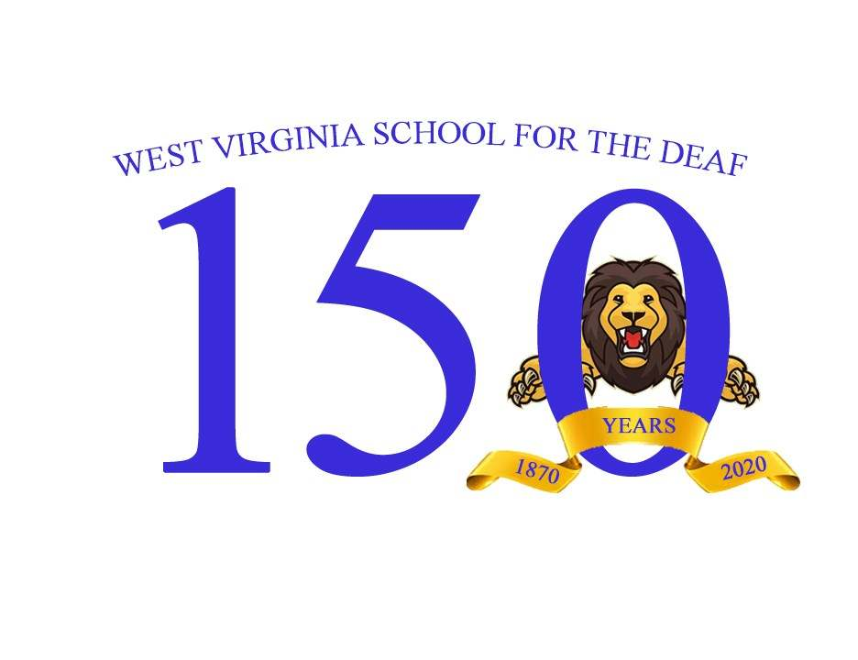
REGISTRATION & EVENTS
Friday, June 10, 2022
Registration & Lunch Gathering
10:00 AM- 4:00 PM
WVSD Pierre Sevigny Hall
6:00 PM – Midnight- Adults Only
Romney Fire Hall
WVSD Hall of Fame Award
Social Night, Games, & Hors d ’Oeuvres
Saturday, June 11, 2022
9:00 AM-3:00 PM
WVSD Seaton Hall
Registration, Group Picture, Campus Tour, Vendors,
…and More!
10:00 AM- Corn Hole
6:00 PM – Midnight- Adults Only
Romney Fire Hall
Formal Banquet
ACCOMMODATIONS
Koolwink Motel
US 50, Romney, WV 304-822-3595
South Branch Inn
US 50, Romney, WV 304-822-2444
South Branch Inn
1500 US HWY 220, Moorefield, WV 304-538-2033
Microtel Inn & Suites
70 N. Tornado Way, Keyser, WV 304-597-1400
Keyser Inn
51 Josie Dr., Keyser, WV 26726 304-788-09313
FOR MORE INFORMATION
visit www.wvsdaa49.wix.com/wvsdaa
Ruby Losh 304-816-0658 VP

REGISTRATION FORM
___________________________________________
Name
___________________________________________
Maiden Name (WVSD alumni only)
___________________________________________
Class of (WVSD alumni only)
___________________________________________
Address
___________________________________________
City/State/Zip Code
___________________________________________
Email
___________________________________________
Videophone Number
___________________________________________
Spouse’s Name
___________________________________________
Maiden Name (WVSD alumni only)
___________________________________________
Class of (WVSD alumni only)
Need Special Accommodation Need? [ ] Yes [ ] No
___________________________________________
If yes, what?
PRICES
$50.00 (Age 18 and up)
Under 17 Years Old- Free
At Door $65.00
Number of Adults ___ x 50.00 = _____
Closing date for $50.00 registration is
Friday, May 6, 2022
Send money order or cashier checks payable to: WVSDAA, Dani Richardson, Treasurer
250 Hannas Road, Romney, WV 26757
Accepted CASH APP: $SparklyCoffee
No refunds on registration will be permitted. Substitutions are permitted only in writing to Dani Richardson, WVSDAA 150th Treasurer.

